**Data Flow Diagrams:**

Project Design Phase-II

Data Flow Diagram & User Stories

|  |  |
| --- | --- |
| Date | 15 October 2022 |
| Team ID | PNT2022TMID06544 |
| Project Name | Car Resale Value Prediction |
| Maximum Marks | 4 Marks |

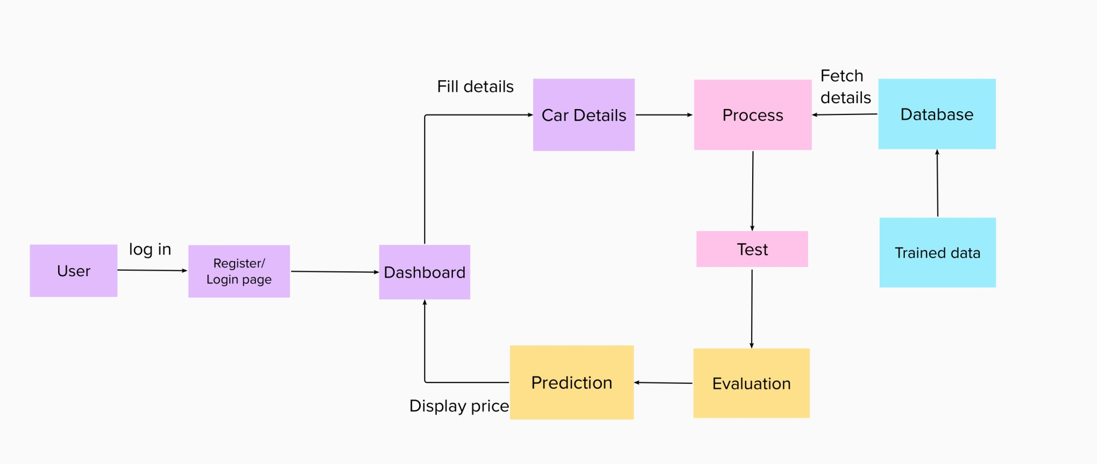

**User Stories**

Use the below template to list all the user stories for the product.

|  |  |  |  |  |  |  |
| --- | --- | --- | --- | --- | --- | --- |
| **User Type** | **Functional**  **Requirement (Epic)** | **User Story Number** | **User Story / Task** | **Acceptance criteria** | **Priority** | **Release** |
| Customer (Web user) | Registration | USN-1 | As a user, I can register for the application by entering my email, password, and confirming  my password. | I can access my account / dashboard | High | Sprint-1 |
|  |  | USN-2 | As a user, I will receive confirmation email once I have registered for the application | I can receive confirmation email & click confirm | High | Sprint-1 |
|  |  | USN-3 | As a user, I can register for the application through mobile number | I can register & access the dashboard using mobile number | Medium | Sprint-1 |
|  |  | USN-4 | As a user, I can register for the application through Gmail | I can register & access the dashboard | Medium | Sprint-1 |
|  | Login | USN-5 | As a user, I can log into the application by entering email & password | I can access the dashboard | High | Sprint-1 |
|  | Dashboard | USN-6 | As a user, I can visit the home page | I can edit my profile | Medium | Sprint-1 |
|  | Car details | USN-7 | As a user, I should give the car details like car model, engine and fuel type, etc… | I should the give car details | High | Sprint-2 |
|  | Car Price | USN-8 | As a user, I can view the current rate of the used car price | I know the car price | High | Sprint-4 |
| Admin | Model Building | USN-9 | As an admin, I should train and test the given dataset | I can build the train and test model | High | Sprint-3 |
|  | Prediction Chart | USN-10 | As an admin, I should send the prediction chart and the nearest service centre location | I can provide chart | Medium | Sprint-3 |
|  | Predict | USN-11 | As an admin, I will predict the price | I can predict the car price | High | Sprint-4 |